**Technical Architecture: Decentralized Micro-Escrow on Stellar and Soroban**

**Components:**

1. **Frontend Application:**
   * Built using frameworks like React or Flutter.
   * Interacts with backend services through APIs:
     + User authentication and account management (Stellar accounts)
     + Project creation and details management
     + Interaction with Soroban contracts (deposit initiation, verification actions)
     + Dispute resolution process management (evidence submission, voting - if applicable)
2. **Backend:**
   * **Stellar Network:**
     + User Wallets and Accounts:
       - Users (clients and freelancers) manage their XLM wallets through the platform, integrated with existing Stellar wallets or hardware wallets.
       - The platform creates and manages Stellar accounts for escrow purposes. These accounts are controlled by Soroban smart contracts.
     + Transactions:
       - Deposits: Clients initiate Stellar transactions through the platform to deposit XLM from their wallets into the escrow account.
       - Withdrawals: Upon successful project completion and fund release, the platform initiates Stellar transactions to transfer funds from the escrow account to the freelancer's wallet.
       - Voting (Optional - Dispute Resolution): If a community voting system is implemented for dispute resolution, Stellar's consensus protocol (SCP) can be explored to facilitate secure and verifiable voting transactions. This requires further research and development.
   * **Soroban Smart Contracts:**
     + Written in Soroban programming language.
     + Deployed on the Soroban network.
     + Manage escrow accounts and implement core escrow logic:
       - Hold deposited XLM in the designated Stellar account controlled by the smart contract.
       - Release funds based on pre-defined conditions within the contract:
         * **Client Approval:** Upon receiving a transaction from the client's Stellar account with a valid signature indicating approval, the contract verifies the signature using Stellar's cryptographic functions and releases the funds to the freelancer's account.
         * **Predefined Criteria:** The contract can be programmed with specific conditions for automatic release (e.g., reaching a deadline, successful file upload verification). The contract interacts with the Stellar network to verify these conditions (e.g., checking timestamps for deadlines).
       - Integrate with oracles (decentralized data feeds) for specific use cases (optional).
         * Oracles provide tamper-proof external data feeds (e.g., file upload verification on a decentralized storage network).
         * The contract can be programmed to trigger fund release upon receiving specific data from the oracle.

**Process Maps:**

* **Process Flow Diagram:** Refer Fig 1
  + User login/registration (Stellar account integration)
  + Project creation (client specifies details, budget, verification criteria)
  + Deposit initiation (client sends XLM to escrow account via Stellar transaction)
  + Freelancer accepts project
  + Work completion
  + Verification and Fund Release:
    - Client approval flow (transaction with signature verification by Soroban contract)
    - Predefined criteria flow (contract checks conditions and releases funds)
  + Dispute Resolution (if applicable):
    - Evidence submission by both parties
    - Voting process (if implemented) or predefined arbitration rules
  + Fund withdrawal (freelancer receives XLM from escrow account.

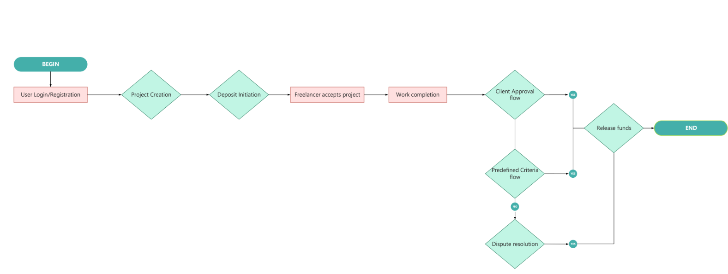

Figure 1

* **Sequence Diagram:** Full sequence diagram shows below:

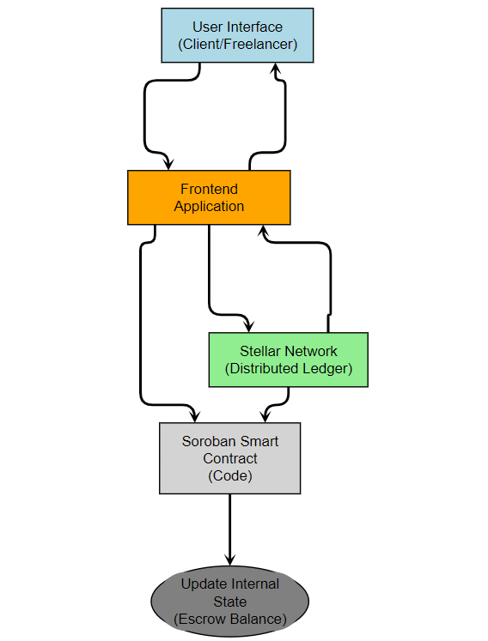

**Figure 2**

**Deposit Initiation Sequence Diagram detailed:**

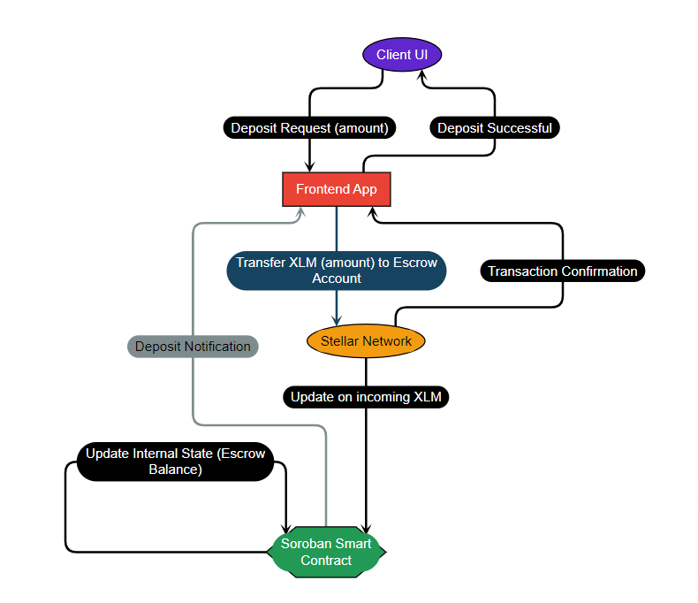

**Figure 3**

**Code Snippets :**

* **Stellar Transaction (Deposit):** (Soroban Smart Contract Code)

This code snippet is part of the Soroban smart contract and handles the logic for processing a deposit of XLM.

**Purpose:** The function handleDeposit verifies if the incoming XLM transaction originates from the expected client account (identified during project creation). If valid, it updates the internal state variable escrowBalance to reflect the total XLM held in escrow.

function handleDeposit(sender, amount) {

// Verify sender is the expected client account

if (sender != expectedClientAccount) {

return;

}

// Update escrow account balance

escrowBalance += amount;

}

* **Soroban Smart Contract (Fund Release on Client Approval):** (Soroban Smart Contract Code)

This code snippet resides within the Soroban smart contract and manages fund release upon client approval.

**Purpose:** The function releaseFunds takes a clientSignature as input. It likely represents a digital signature generated by the client's Stellar wallet to approve the release of funds. The function verifies the signature using Stellar's cryptographic functions and, if valid, initiates a Stellar transaction to transfer the entire escrowBalance (total XLM held) to the freelancer's account.

function releaseFunds(clientSignature) {

if (verifyClientSignature(clientSignature)) {

// Send XLM from escrow account to freelancer

stellar.sendPayment(freelancerAccount, escrowBalance);

escrowBalance = 0;

}

}

* **Soroban Smart Contract (Predefined Criteria - Deadline Check):** (Soroban Smart Contract Code)

This code snippet is part of the Soroban smart contract and demonstrates an optional functionality for automatic fund release based on pre-defined criteria.

**Purpose:** The function checkDeadline retrieves the current time (currentTime) and compares it with the project deadline (projectDeadline) stored within the contract. If the current time has surpassed the deadline, it triggers the releaseFunds function, effectively releasing the escrowed XLM to the freelancer.

function checkDeadline() {

currentTime = getTime();

if (currentTime >= projectDeadline) {

releaseFunds();

}

}

**Security considerations:**

The security of Decentralized Micro-Escrow platform is paramount for building trust and ensuring user adoption. Here's a detailed breakdown of security considerations across different components:

**1. User Authentication and Authorization:**

* **Stellar Accounts:** Leverage Stellar accounts for user authentication and authorization.
* **Secure Wallets:** Integrate with existing secure Stellar wallets or hardware wallets for user control of their XLM.
* **Multi-factor Authentication (MFA):** Implement MFA for additional security at login and for high-value transactions (deposits, withdrawals).
* **Role-based Access Control (RBAC):** Define clear RBAC within the platform to restrict access to sensitive functionalities (e.g., project management for clients, contract administration).

**2. Smart Contract Security:**

* **Auditing:** Conduct thorough audits of Soroban smart contracts by reputable security firms to identify and address any vulnerabilities before deployment.
* **Formal Verification:** Explore formal verification techniques to mathematically prove the correctness and security properties of your smart contracts.
* **Secure Coding Practices:** Follow secure coding practices in Soroban to minimize the risk of introducing vulnerabilities.
* **Bug Bounty Program:** Will launch a bug bounty program to incentivize the security research community to identify and report potential issues.

**3. Network Security:**

* **Stellar Network Security:** Rely on the security of the Stellar network for transaction processing and account management.

**4. Dispute Resolution(Optional):**

## 

The Decentralized Micro-Escrow platform aims to facilitate secure and transparent transactions between clients and freelancers. However, unforeseen circumstances can lead to disputes. While implementing a dispute resolution mechanism is optional, it can provide a valuable safety net for users in case of disagreements. Here, we explore two potential approaches:

**A. Community Voting:**

* **Concept:** Leverage the power of the Stellar network community to vote on dispute resolutions.
* **Process:** Both parties involved in the dispute can submit evidence to the platform. The community then reviews the evidence and votes on a predetermined resolution (e.g., full refund to client, partial payment to freelancer).
* **Pros:** Decentralized approach, leverages community wisdom, potentially faster resolution.
* **Cons:** Requires active community participation, potential for Sybil attacks (where one user controls multiple votes), subjective judgment from voters.

**B. Predefined Arbitration Rules:**

* **Concept:** Establish a set of pre-defined rules within the Soroban smart contract to govern dispute resolution scenarios. These rules can be based on factors like milestones achieved, communication records, or deadlines met.
* **Process:** Dispute resolution relies on pre-defined criteria within the smart contract. Both parties submit evidence, and the contract automatically adjudicates based on the coded rules.
* **Pros:** Objective and transparent, reduces reliance on subjective judgment, potentially faster resolution for clear-cut cases.
* **Cons:** Less flexible than community voting, requires careful design of rules to cover various scenarios, potential for disputes arising from rule interpretations.

**5. Platform Security:**

* **Secure Coding Practices:** Implement secure coding practices throughout the platform's backend to prevent common vulnerabilities (e.g., SQL injection, cross-site scripting).
* **Regular Security Audits:** Conduct regular penetration testing and security audits of the platform infrastructure to identify and address potential weaknesses.
* **Data Security:** Implement robust data encryption practices for storing sensitive user information (e.g., usernames, passwords).

**Additional Considerations:**

* **Smart Contract Upgradeability:** Design Soroban smart contracts with upgradeability mechanisms to allow for future bug fixes and feature enhancements while maintaining security.
* **Transparency:** Publish the source code of Soroban smart contracts for public scrutiny and to promote trust.
* **User Education:** Educate users on best practices for secure wallet management and interaction with the platform.

By implementing these security considerations throughout the development process, create a robust and secure Decentralized Micro-Escrow platform that fosters trust and encourages user adoption within the gig economy.